* EBS
* IOPS
* Root vs additional volumes and
* snapshots

**EBS**

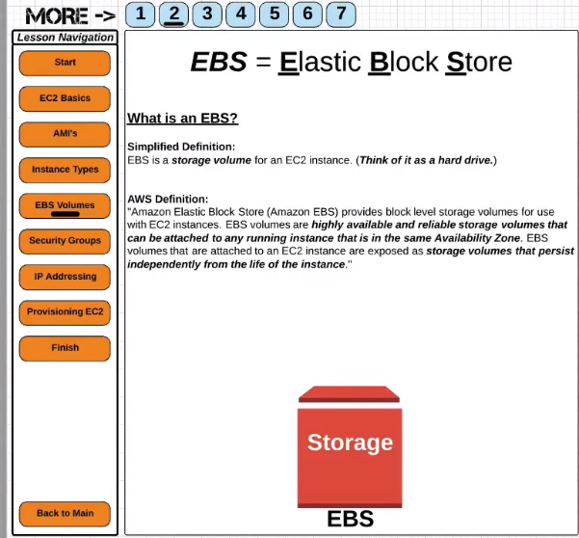

1. EBS is a storage volume for ec2 instances. So here I want you to think of it as a hard drive.
2. As per AWS definition, elastic block store provides block level storage volumes for use with ec2 instances.
3. EBS volumes are highly available and reliable storage volumes that can be attached to any running instance that is in these same availability zone.
4. EBS volumes that are attached to an instance are exposed as a storage volume that persists independently from the life of the instance.

**IOPS:** input/output operations per second.

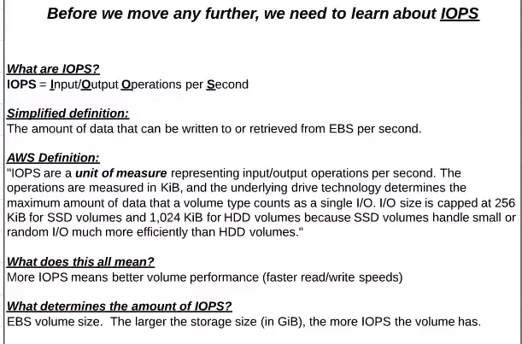

the amount of data that can be written to or retrieved from an EBS volume per second.

AWS defines IOPS as a unit of measure representing input/output operations per second.

The operations are measured in KiB.

IOPS size is capped at 256 KB bits for SSD volumes and 1024 kb bits for HDD volumes because SSD volumes handle small or random i/o much more efficiently than HDD volumes.

**More IOPS means better volume performance faster read/write speeds.**

**What determines the amount of IOPS???**

well the largest contributing factor is the EBS volume size.

So the larger the storage size and gigabytes the more IOPS the volume has.

**Root vs additional volumes:**

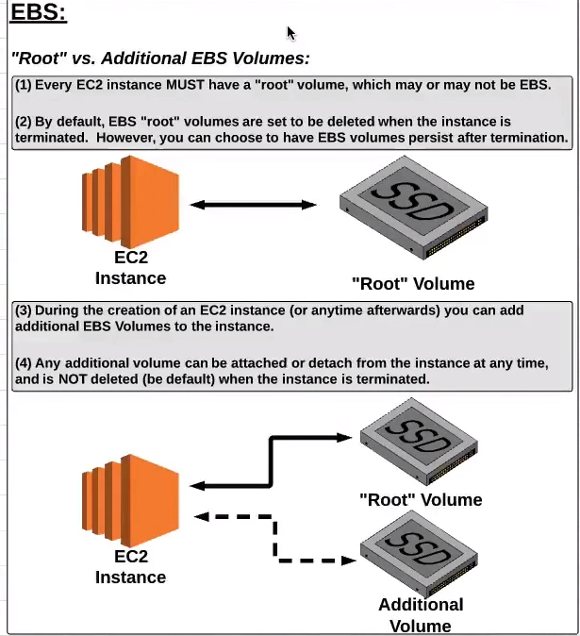

let's be clear about this every ec2 instance must have a root volume which may or may not be EBS .

So EBS is not the only type of storage offered by Amazon Web Services for ec2 instances but it is the most commonly used.

You can goto ec2 console you can go to elastic block store and view your volumes.

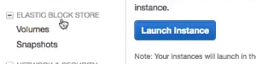

if you want to you can create a volume independent of an ec2 instance

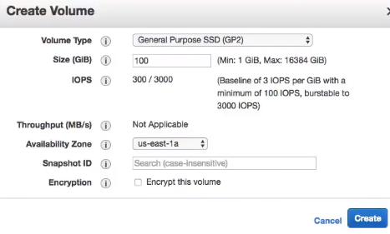

or during the instance creation process

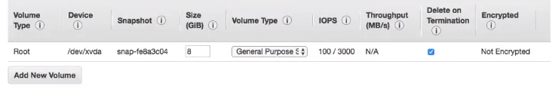

Where we select route volume for your ec2 instance… and by default this is an EBS volume..

By default EBS route volumes are set to be deleted when the instance is terminated however you can choose to have the EBS volume persist after termination.

**major benefits of EBS volumes versus older types of storage volumes**

1.)EBS volumes can persist past the lifespan of EC2 instance.

delete on termination and that is checked that means that when we terminate this instant this EBS route volume will be deleted as well… but if I were to uncheck this then I can terminate the instance and this EBS route volume would still be there in my account which I could then attach to a different ec2 instance.

2.)if I want to I can also add an additional volume and EBS volume to my ec2 instance during the creation process of the ec2 instance or I could always create an EBS volume anytime afterwards and attach it to the ec2 instance.

3.) So this means that we can swap EBS volumes between different easy-to instances by detaching it from one and attaching it to another.

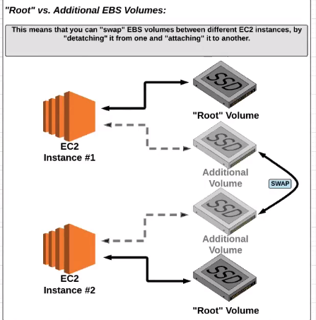

If I were to create this ec2 instance and I have my root volume and then I have my additional EBS volume just like I have here…, I can then at some point in the future create a second ec2 instance maybe just with a root volume but I can then take this additional EBS volume detach it from instance1 and move it to instance2…So it's a really nice feature to be able to basically take hard drives and move them or swap them from one instance to another.

When you think about route vs. additional volumes **what I want you to think about is i**f you have a computer at home you probably have a hard drive that is built into the computer so if you were to take the computer and throw it in the garbage or the computer were to break ..,then most likely you would also lose the root volume unless you were to actually open your computer up and take that hard drive out.

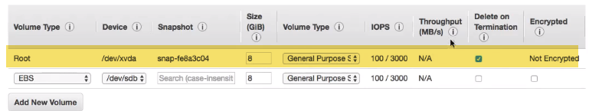

So think about that the same way here with your root volume this is the hard drive that is built into your computer and you have the option to either when you terminate or when you would throw out the instance.., you would have the opportunity to open up the computer and actually pull that hard drive out and save it for later… by unchecking (delete termination) this here but if you keep it checked that (delete termination) would be similar to you taking your computer right now and throwing it in the garbage and having the hard drive inside go with it with.

**Additional volumes is** like having an external hard drive. So if you have a thumb drive an SD card or a solid-state drive that maybe you plug into your computer but is external and

what you can do with a thumb drive or an external hard drive is just unplug it from your computer and go plug it in to another computer at any time and that's what it's like here having an extra EBS volume.

**snapshots**

* snapshots can be viewed right here under the elastic store volumes.
* a snapshot is an image of an EBS volume that can be stored as a backup of the volume or used to create a duplicate. A snapshot is not an active EBS volume you cannot attach or detach a snapshot to an ec2 instance.
* However, to restore a snapshot you need to create a new EBS volume using the snapshot as its template.

If I have an EB s volume and I create a snapshot that is basically a duplicate or a replica that I can use as a backup to store and at some point in the future I can launch a new EBS volume and make and use the snapshot to populate the EBS volume with all the information that was on the original EBS volume.

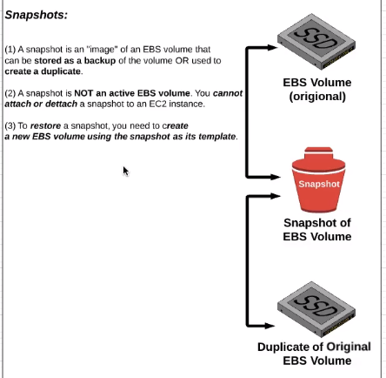

**So the benefits of snapshots are to have a great resource for backups and having a snapshot because it is not a live active EBS volume is also a lot cheaper**..

AWS EBS Tutorial | Amazon Elastic Block Store | Simplilearn

1.) EBS provides persistent block level storage volumes for use with Amazon ec2 instances in AWS cloud.

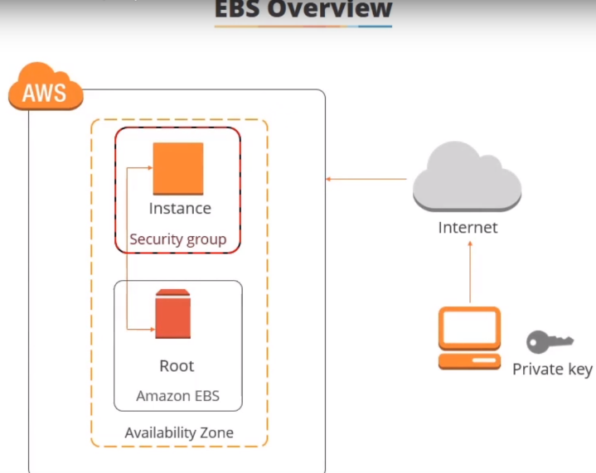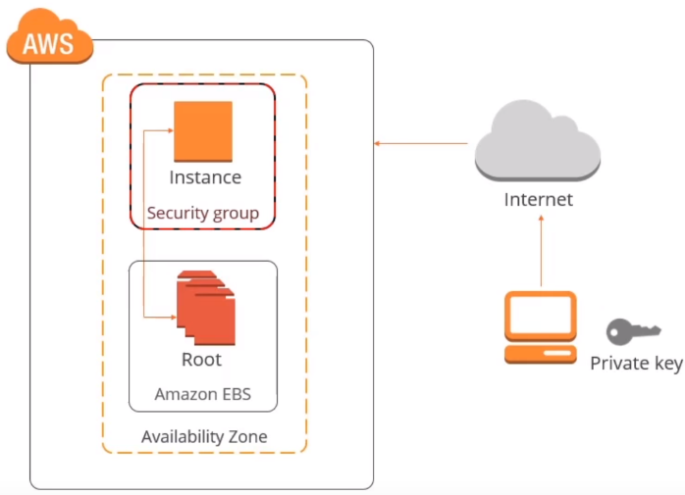

Each Amazon EBS volume is automatically replicated within its availability zone to protect you from component failure to offer high availability and durability.

So basically, EBS is the disk volumes that you attach to your ec2 instance.

2.) you can create an EBS volume in the management console.

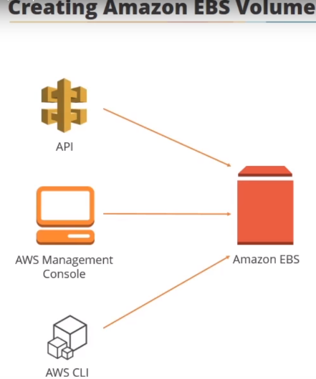

When you create a new EBS volume, you need to define the region and the availability zone for it.

You can also create new volumes through Amazon API or command-line tools.



Note that the size of the volume availability zone and the volume type is defined in the command.

The region is assumed from the default settings of AWS CLI.

**you can also copy a volume to a different region using snapshots.**

3.) EBS volumes can be stripped raid zero for performance or configured redundant storage raid 1 by using raid arrays.

You can create raid arrays by using the standard operating system tools.

4.) you already know you can back up the data on your EBS volumes to Amazon s3 by taking point in time snapshots. 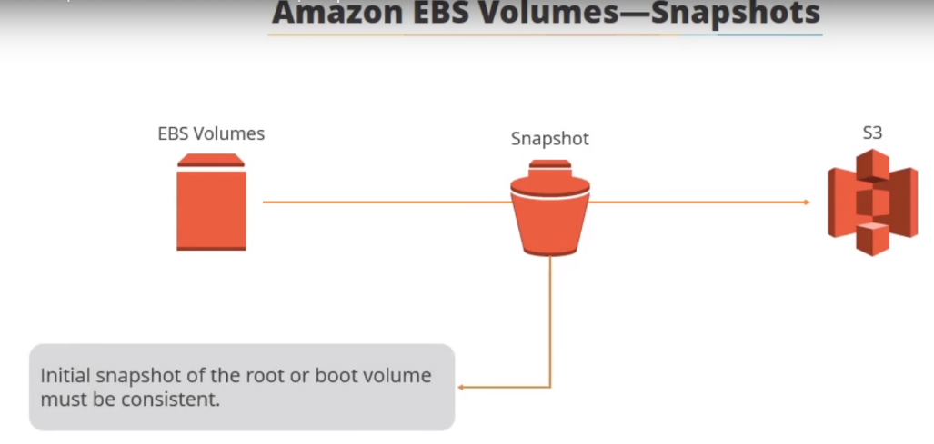

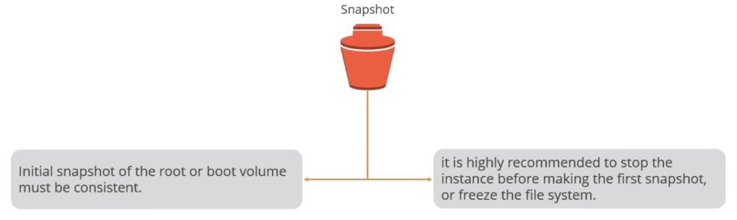

Initial snapshot of the root or root volume must be consistent so it is highly recommended to stop the instance before making the first snapshot or freeze the filesystem.

5.) scale an Amazon EBS volume using snapshots:

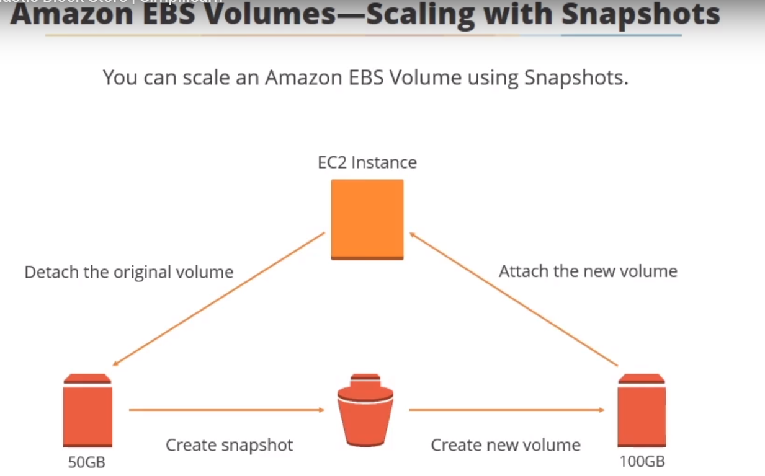

If you are performing the process on the root volume be sure to stop the instance before detaching the original volume detach the original volume if it is the root volume then you will have to perform this action from the management console or from another Amazon ec2 instance that will continue running create a snapshot of the detached volume use the AWS ec2 create volume command to create a new volume you can specify in the command that the volume will be created from the snapshot you previously took of the smaller or larger volume attach a new volume to the stopped ec2 instance and if you expand the root volume restart the instance…

**Manage snapshots:** keep in mind to better manage snapshots:

use automation to manage a large number of snapshots across a large fleet

use CLI tools to automate creating and managing snapshots through Linux shell and windows batch create backup commands using CLI and schedule them through cron for Linux or task scheduler for Windows

use services such as AWS data pipeline or configuration management systems like chef to setup scheduling tasks remotely

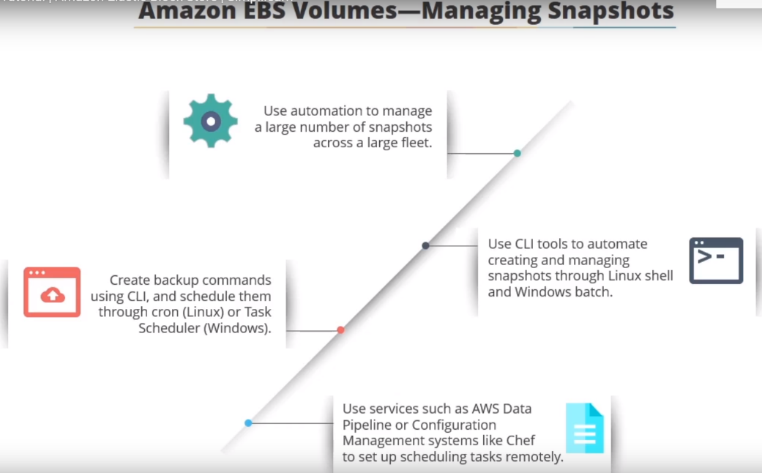

on this screen CLI commands for three common snapshot management operations are displayed:

* taking the snapshot
* moving the snapshot across regions and
* finding the snapshot ID and restore it to a new volume

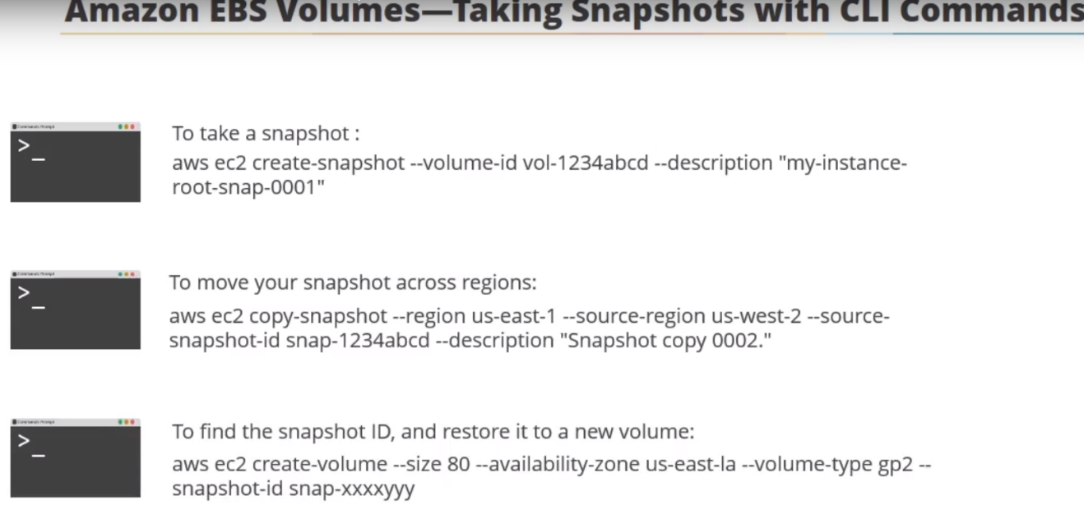

Although snapshots are stored in Amazon s3 they are not directly accessible using the Amazon s3 utilities… you need to use the Amazon EBS tools to restore and manage snapshots.

In this demonstration we're going to take a quick look at EBS snapshots

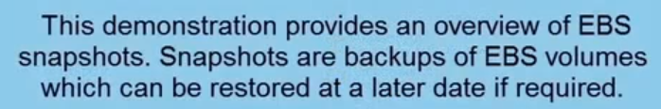

ec2 -🡪volume section.

Now here are the two volumes the root volumes that are attached to our simply learned web servers so I've tagged them is simply then web server one root and website of a two root.

 To create a snapshot:

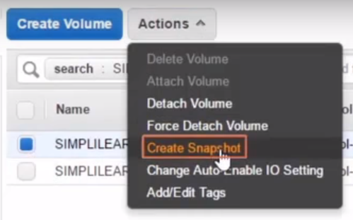

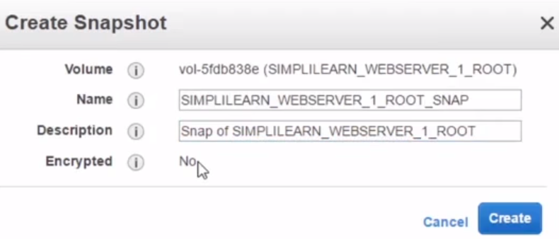

encryption no: because the root volume isn't encrypted if this was an encrypted volume then this would also be an encrypted snapshot .

**we could take a snapshot every night or every week of the web server. So we can restore to a point in time or if we wanted to we could create a volume from this particular snapshot.**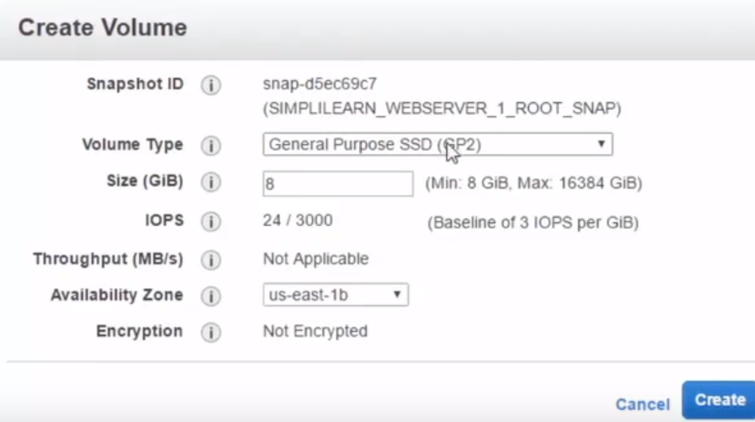

we can change the availability zone… So once you have the snap you can do pretty much anything with it in your region…

you can also create an ami from your EBS: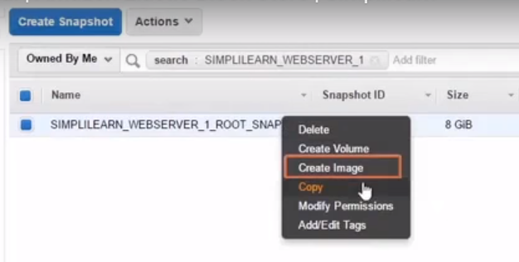

# How to use AWS EBS(Elastic Block Store)--valaxy

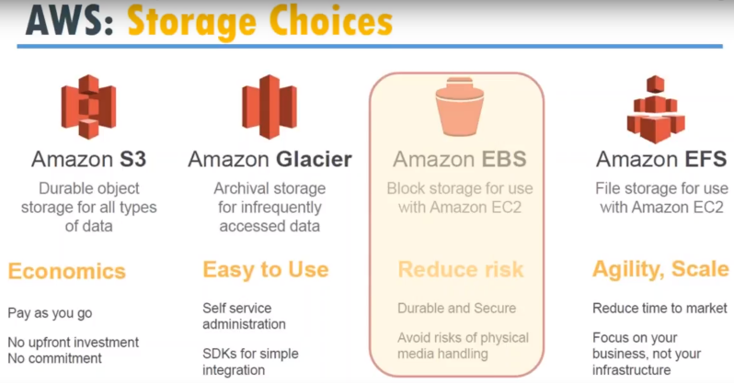

1.) Block storage for your compute instances on your servers.

You can think of it as an externally attached storage that is like an you think of it like a meta or EMC storage attached to your server.

But it is a very very crude analogy I should say because of the data and the disks and the performance all that is differs from compared to an externally attached storage.

**what is EBS???**

You can think of it an external disk ..,but it is not an external disk.

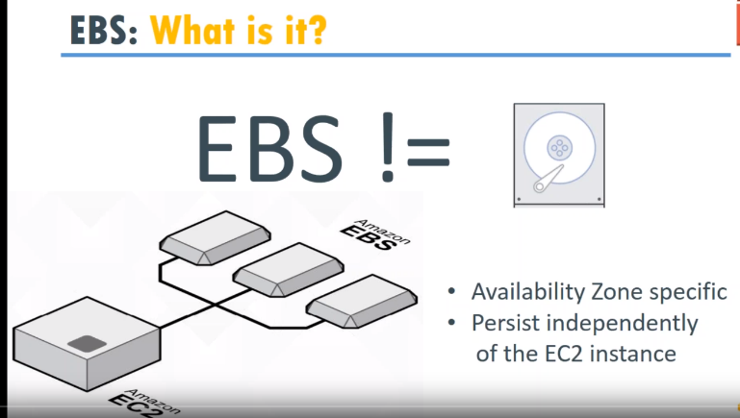

1.)If you remember there are availability zones in each region…

When you create an ebs volume., these volumes are specific to that availability. If you want to **move that from one availability zone to another zone** it is not very possible., You need to take a snapshot put it into a S3 bucket and then move from one s3 bucket to another s3 bucket.

2.)you can have **one external disk or multiple external disk** or you can have any number.., that is available for you and as you need it you can assign it to it easy to compute instance.

So, we have three volumes attached to your server.

3.) It is also **independent of Ec2 instance.(SWAP)**

When you detach it from the server, the data or information that is available in your EBS is persistent. it doesn't go away so you can take EBS and assign it to another server and start using it .

Here, you have an EC2 instance which was previously running and become faulty for some reason… that might be a hardware failure or that might be in number of causes…

**For example:** you move from application group from one version to another version. So instead of upgrading…. what you did was you created another ec2 instance here on a install your latest application and you want to connect it to your data which is in the external EBS.. so what you do is you detached from this instance you attach it to this instance it is just a few clicks when you want to detach and if you're falling and is it to another server.

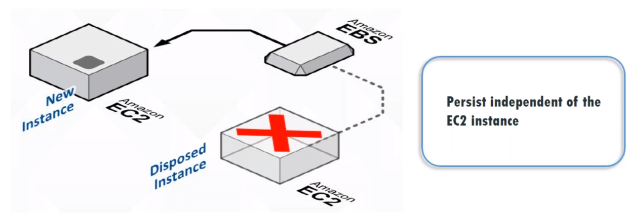

**If you want to move data from one server to another server you just detach and reattach to an instance …**This is what Amazon means by persistent independently of EC2 instance..

**interview questions:**  how do you move data from one server to another server??

will you use the networks or ebs volume or s3??

🡪 if available, use EBS which has high IOPS performance is higher and it is good inside your networks You can move it to an s3 and then copy the data back from s3.., then that means that that is more bandwidth cost that is in word for sending the data out of your VPC and putting it back again.

Your answer should be: I will use EBS volumes and if EBS is not enough… for example you want more terabytes of data or more huge, then only you will look at s3 as an option to move data.

4.) each server needs and root disk and that route this usually comes from EBS volume.

To create volume:

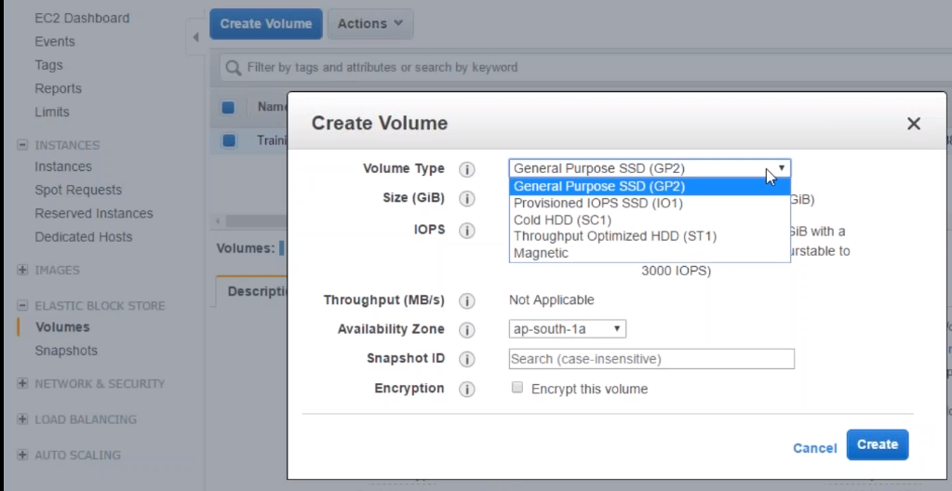

I'm having an instance running in 1a, So I need to create volume in 1a..

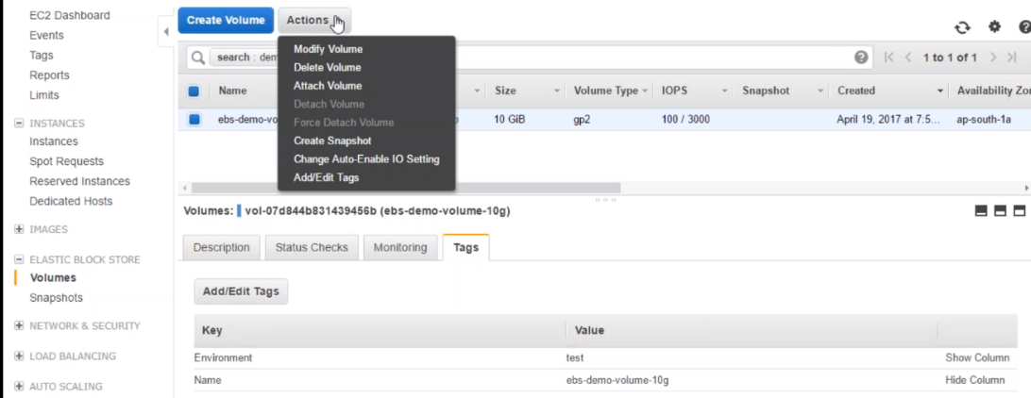

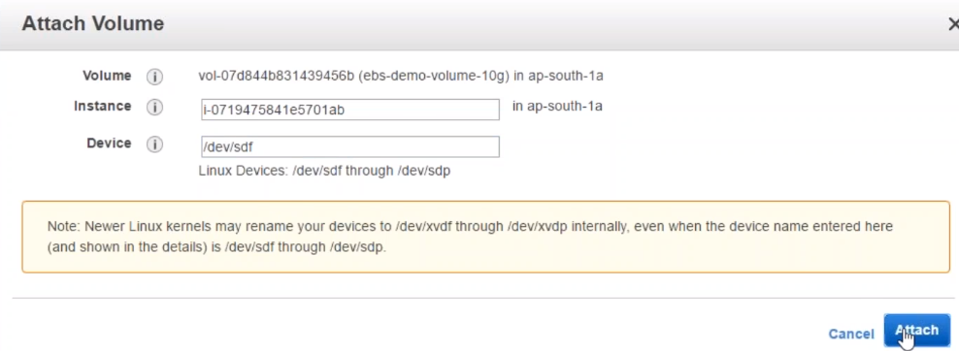

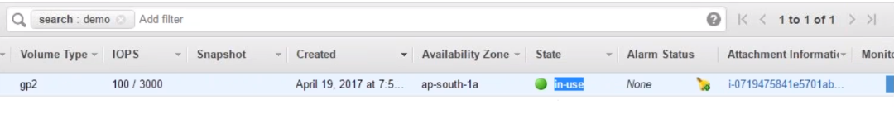

VOLUME is in use …So you cannot attach the EBS volume to more than one instance at the same time.

So I have attached it to an instance called training instance so if I want to attach it to other instance I need to detach it from the first one and then reattach it to a new one…

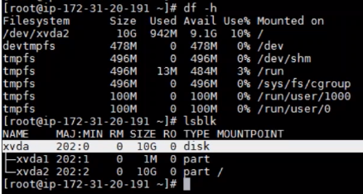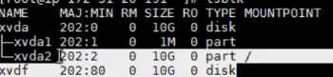

You can notice the difference we have something called disk part available…

I'm just going to create a directory..

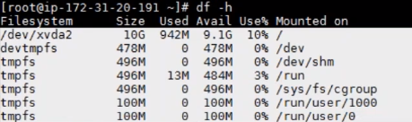

you will not see the one you mounted in here…

Snapshots:

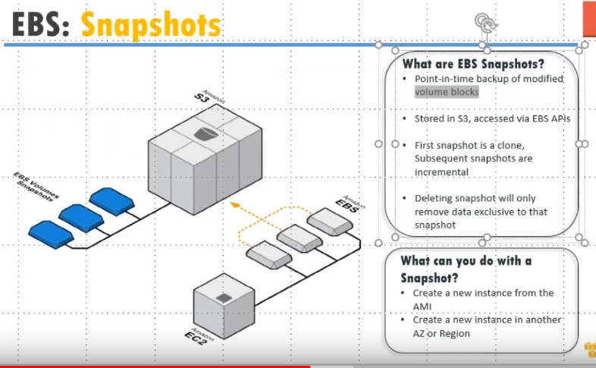

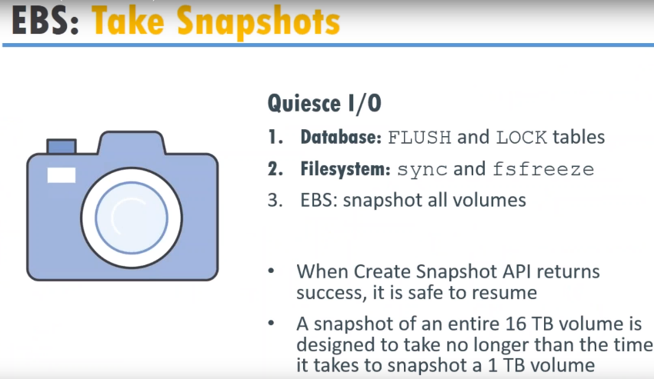

when you are doing the snapshots what are usually Amazon does is it stops all the i/o if you it doesn't stop all the i/o.

**for example** if you're doing a snapshot on a database instance or a database server it is your responsibility to flush all the I/O and drop all the tables.

In other words no I/O should be happening ..

**snapshot** everything which is on this memory is dumped into another disk in a flash and then a volume is created for you so at that point of time if there is an:

* I/O happening or
* a half-written file is,
* there are lock on a particular file….

that will create inconsistencies in your snapshot .and you will have difficulties in Mounting that volume and retrieving all the data.

So it is always and almost always recommended is that you stop Quiesce I/O (technical word)..

for database: flush it and lock the tables and

* FS: sync it and do an fsfreeze and
* then you snapshot all your volumes

If your snapshot is writing an entire 16Tb it takes about snapshot about a 1 TB.

**interviewers** how do you take a snapshot of a database server ???

So you tell them I stopped the i/o and then I take a snapshot and then I start I/O..

You can do this by stopping your application server traffic or in a database level you can introduce a lock on all the tables and then do that…

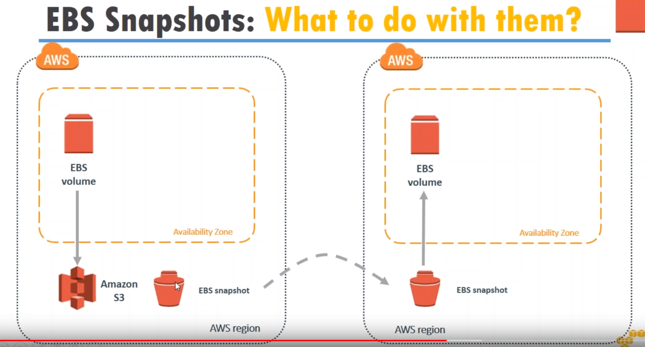

We had this EBS volume and we created a snapshot and we moved it to another availability zone …But in this example diagram , that you see there I can also move it to another region.

If I want to move to another region you need to see the symbol here this is an s3 bucket I'm going to copy it from one region to another region bucket and then I am going to create a Volume from this..

**But in our example or demo, I am going to show you.. how the move to other AZ…**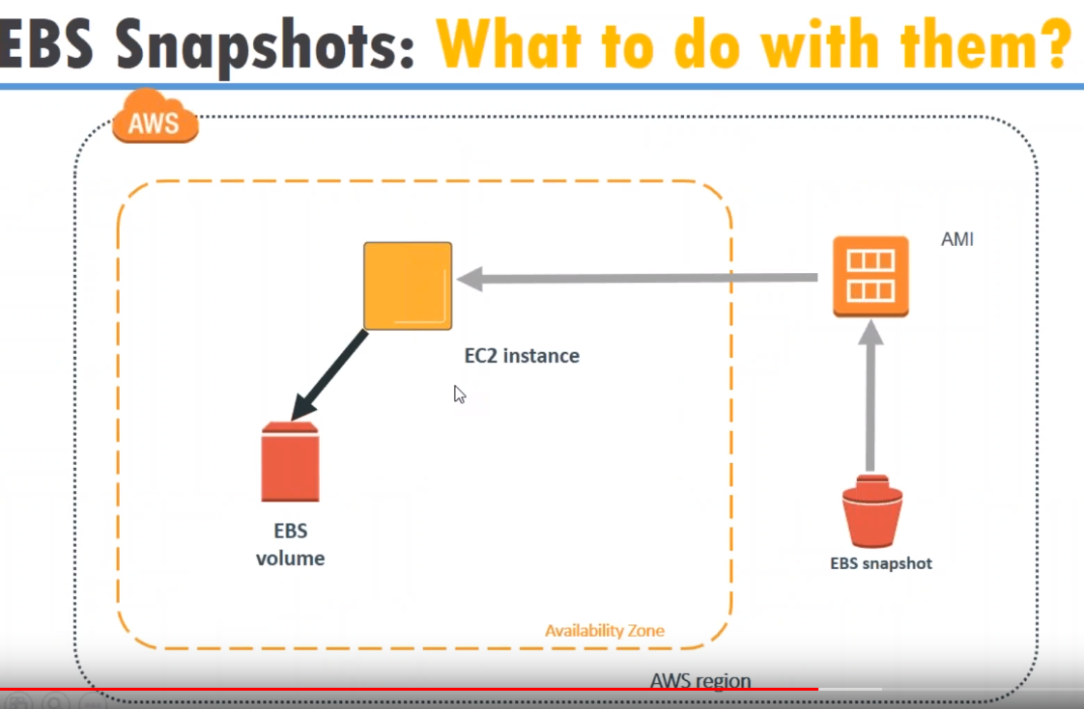

From Snapshot, I can create AMI ( server image).

Let us say your snapshot is having the root volume snapshot.., if it is a root volume then I can create an instance from the root volume and start another server in other availability zone…

So in other words..., let us say you've created a server and customized it completely to install WordPress you install MySQL.. install some Administrative Tools and everything is ready to use..

Now, you want to give share this image to your customers or your other teams then what you want to do you want to give them the instructions or you can **give them a snapshot of your volume and they can create an AMI that and start a server** from that so all your config. , all your customizations are instantly passed from volume snapshot to the server directly…

This is one of the other purposes customers will use it….

They build DEV environment ,do all this testing and when they want to move into production or in other words do a cut over …, they take a snapshot and restore it in the production environment and all the configurations that you have done in DEV and tested and fine is already in production …you don't have to see build anything in production…

**Encryption:** Now if you remember I did not take this mark in the beginning.

So if you want to do encryption for your EBS:

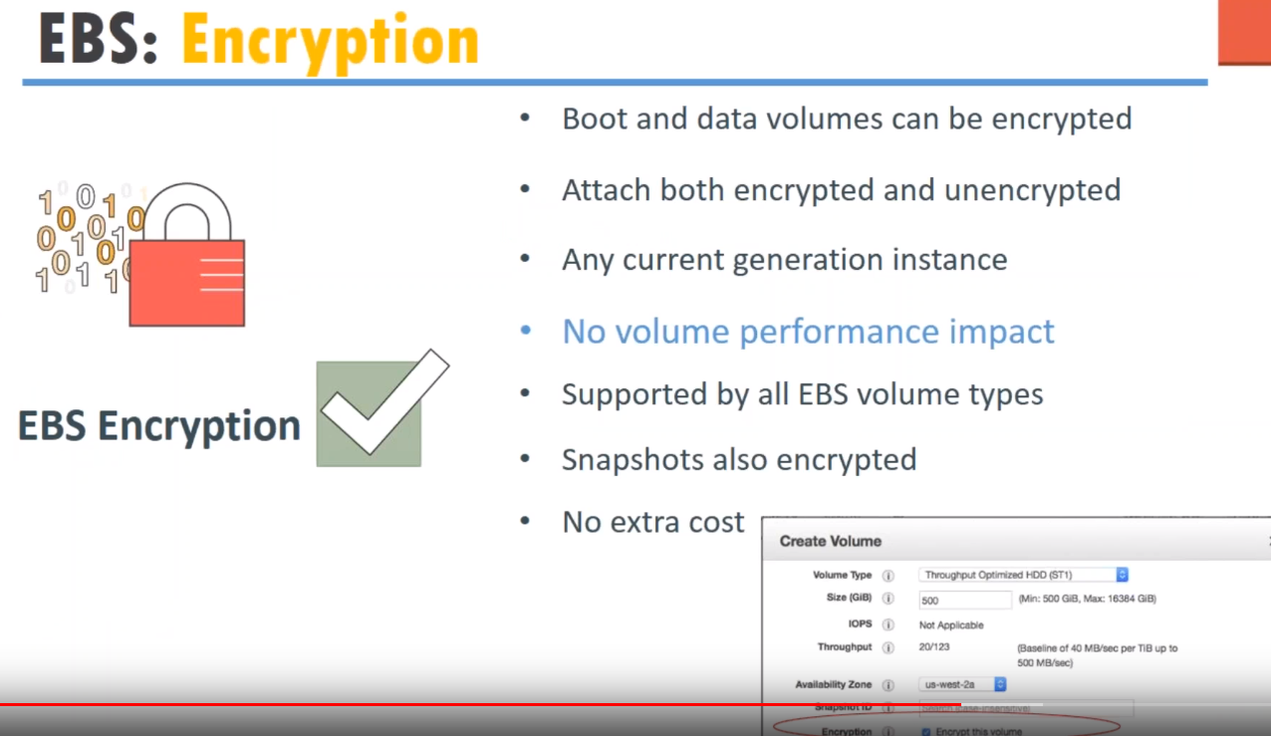

create volume , which you can encrypt…

encryption has a master key for encryption and data will be encrypted using the master key.

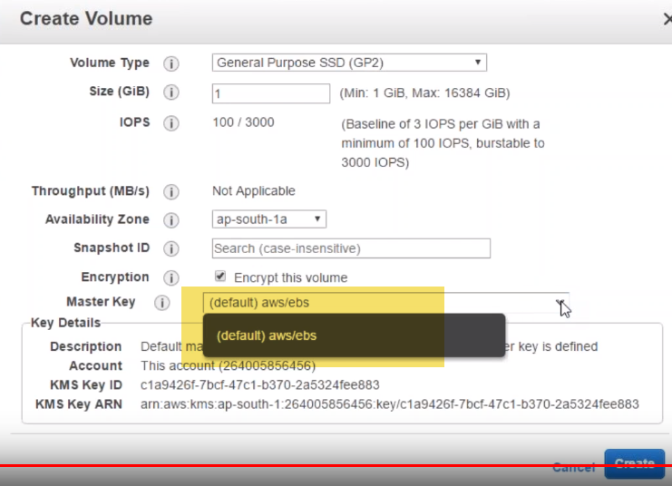

So if I am going to say Amazon use your master key by default and interpret for me.

If I dont what Amazon to use its own key what I need to do is I need to upload my key into Amazon and say Amazon use the key and it will come into the drop down list by default …I am not having any key so it shows me only this option..

Technically what I've seen is usually in the conventional data centers or conventional models encryption introduced a small performance impact in two volumes especially in databases and operating systems…

But what Amazon says is encryption is truly transfer **and you don't see in performance impact by encrypting and walling that is a encrypting and decrypting happens on the fly on your PC to instance and you don't see a performance impact because of enabling encryption..**

..

it is saying volume is enccypted with that KMS ID..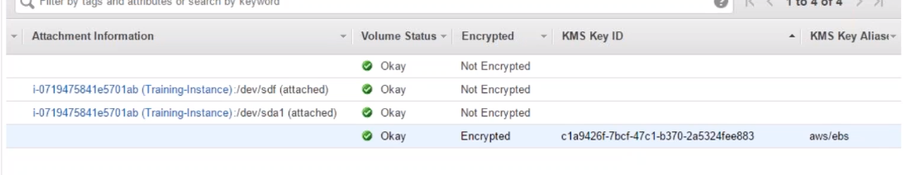

**So you mount, create snapshot, share it**

**will always be encrypted so if you are giving it your customers you need to give them the key as well..**

for them to decrypt it otherwise nobody even if you lose the key you will not be able to retrieve the data..

Encryption introduces an additional management thinking that is when you are creating a snapshot and if you are moving to a region a different region.., that region also should have access to the same encrypted keys.. That is why it is better to leave Amazon to do the key management mostly.

So that Amazon will take the key and distributed to all your regions but if you do it and miss it over to another region and try to mount it to the server you will not be able to mount and create that volume.

NO performance impact in volume encryption…because whenever I created a volume or in a database in Oracle db2 any acts as a considerable performance impact I have seen in my life

Any snapshots that you create or share will also have the encryption enabled .

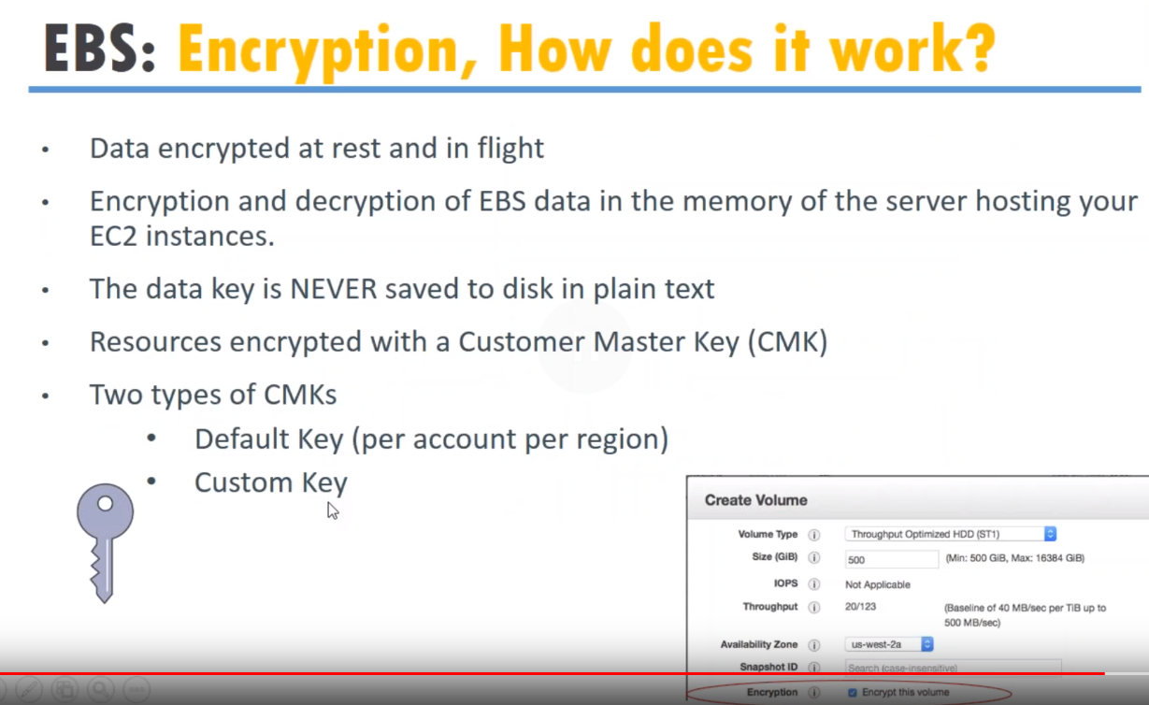

There are two types of key management that is the **default key or custom key…**

remember the data key is never stored to the disk in plain text.. Even if you upload your key Amazon includes that the key with this own key and writes it to a disk..

key is never stored as plain text and your key is all this is secured with Amazon encryption…

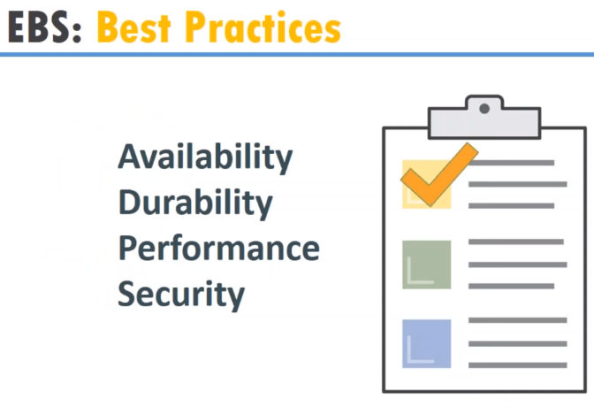

**QUESTION** : if I have it 10 snapshots.., how do I create a snapshot and restore it to other machines??

🡪 well it is laborious in other words a human intensive you need to manually create the snapshots for each and every one

What companies have is ..They usually have a script and in the script they will just give a parameter as these are the volume IDs like I want to give take a snapshot for …

This script will usually be written in BOTO or in lambda and it will take the snapshot for you…

In other words always you need to remember what is the volume IDs that I want to take snapshot for it might be 10 or 100 ..

Let us say 20 volumes is very very big Big for enterprises. As I told you each volume is capable of storing 16 terabytes of data

**So you want to find many instances with multiple volumes probably will find two or three and each of them will be big sized so that the number of snapshots that you will take will be considerably lesser..**

**QUE-2:** Suppose I created EBS under the general purpose…But my instance under different…Can I add EBS volume to that instance???

-🡪There is a matrix for example there are instances like a t2 that is the very very less size instance. Those instantly not support provisioned volumes..

Instances like M series..,m3 m4 or C series which is compute optimized can suppose on secrecy??

In other words not all EBS volumes are supported in all instances all servers so when you are choosing your instance type

**best practices is to choose the right instance and the right volumes for you**

In case of general 🡪you have to use the General purpose IOPS…

Based upon the IOPS operation can choose the VOLUME types…

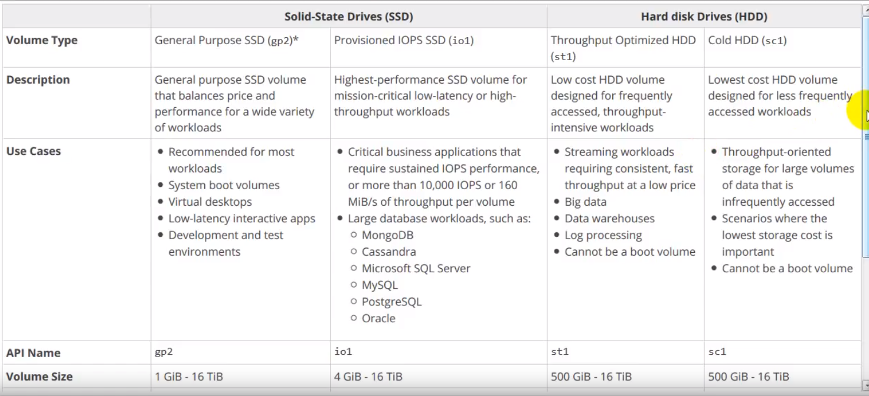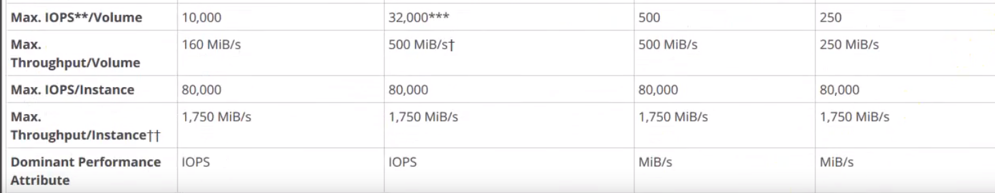

EBS volume whether it is connected to the server or not your data will be available…

Here, you have AWS region inside it you have to availability zones and I have created a simple EBS volume ..let us assume it for that moment..

Now, Amazon is automatically creating a replica…

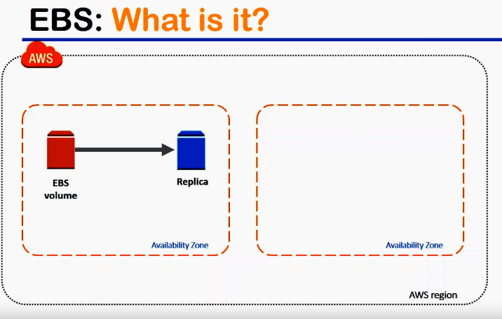

In this way, you get redundancy of your storage or durability of your storage automatically.. If for some reason, this EBS volume goes offline the blue color copy will become the primary copy.

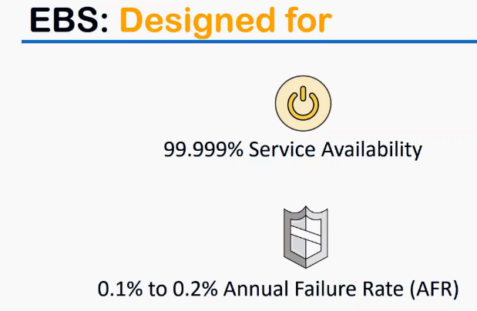

So this translates into a five nines of service availability ….

let us say our 999 thousand times ..,you are trying to access your disk there will be only one failure

and that is very very less compared to Onpremise disk storage of world by most vendors..

Also, Amazon calculated failure rates for their disks is ranging from 0.1 percentage to 0.2 percentage.

in an annually calculated total number of disks that Amazon supports only 0.1 percentage of their disks are failing…That is what AFR means…

**TYPES OF STORAGE:**

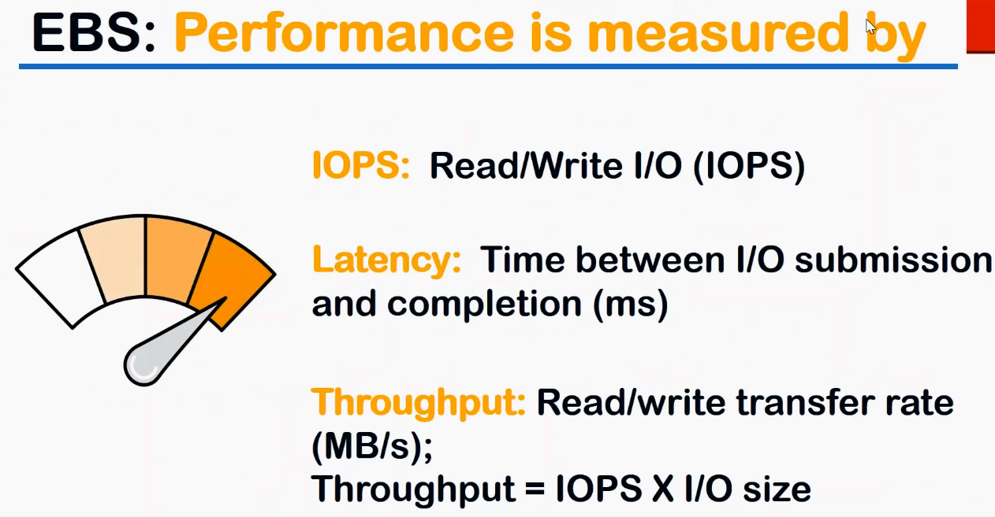

When we talk about performance it is measured in two ways predominantly...

It is measured by **IOPS** (number of read and write operations per second).. So typically some companies use it as a 64 KB/read&write or some companies will measure input as once size and output as another size.

**latency** : time between the submission of the Write and then the completion of that Write or the time between submission of the read and how much time it completes to the read…

Ex: When you type [www.google.com](http://www.google.com) …How much time does it take to render page…

Request goes to DNS server-🡪DNS server to actual web server-🡪 reads the content from the database or some data store and pushes the content all the way back to browser…

How much time this whole operation takes is a latency of your network level …but if we are talking about our network latency at an i/o level that is a disk level… So how much time that Disk itself takes for i/o… So this latency is at the disk level that is what you should remember …

Usually when people talk about latency.. they will be talking about latency at a network level…

**throughput** how fast I can write and read and write in key to my disk that is all told I opt into the i/o size

These are different parameters the performance is measured…

When we are talking about block storage so let us see which one you should choose what is more important to your workload that is the o**ne important question that you need to ask your clients is your application more dependent and dependent on IOPS or you is your application more dependent on throughput…**

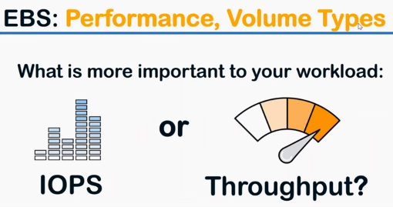

**Example:** Formobile applications are more dependent on IOPS because amount of data that transacts is less than 1 KB most of the time… So you are going to read and write a lot of requests for millions of devices but very very small request…

But when you are looking at a movie streaming content or a video streaming content **throughput** this maximum because we are looking at a 4k definition file and they think of some 10,000 users are trying to stream a 4k movie… So you want to look at how much throughput I can achieve or how much bandwidth I can achieve.

So depending upon your application you need to go for IOPS optimize the disk or a throughput optimized disk..

Block size determines whether your application is IOPS bound or throughput bound. So how do I know??...

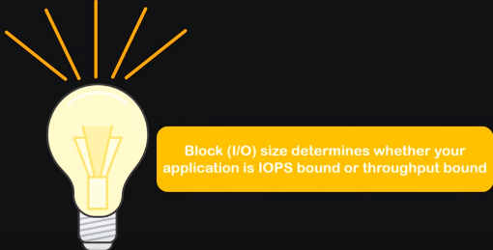

This block size typically what you do is : you go and talk to your application developer and ask them how much data they are going to write it to the database or how much data they are going to read from the database or any storage at any given point of time…

So they will know that I am going to query this much data and the database will be responding me with all this data and you will come to totally about 1 MB of data or 1 KB of data…

So based on that now you will know your block size and from there you can go to IOPS or to a throughput…

That is how you identify which is suits your application.

IOPS:

you can achieve a 20,000 IOPS at the maximum level as one today .That is the maximum performance Amazon EBS volumes gives you… and

When you are talking about the throughput, you can achieve a maximum throughput of 320 MB/sec..

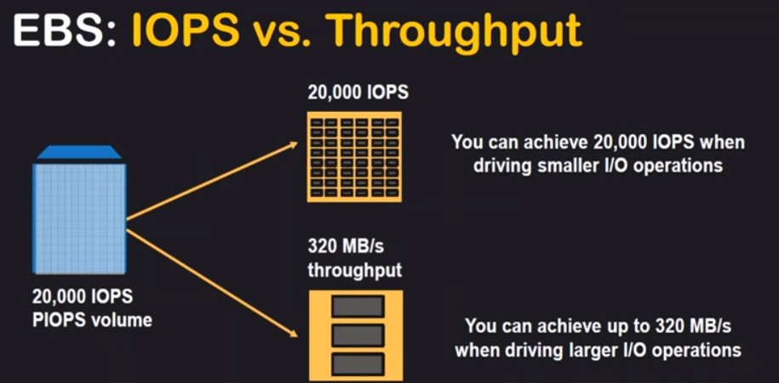

Remember this is a disk limit… if I say about two disks so I can have a total throughput of about 40,000 iOPS because each this allows me to have 20,000 IOPS. and in total I can have a 40,000.

likewise troughput of 640MB/sec… So I need to do some configuration ,so the data is replicated.

So I can read and write from both disks at the same time..

each block store can scale up to 4 TBs..

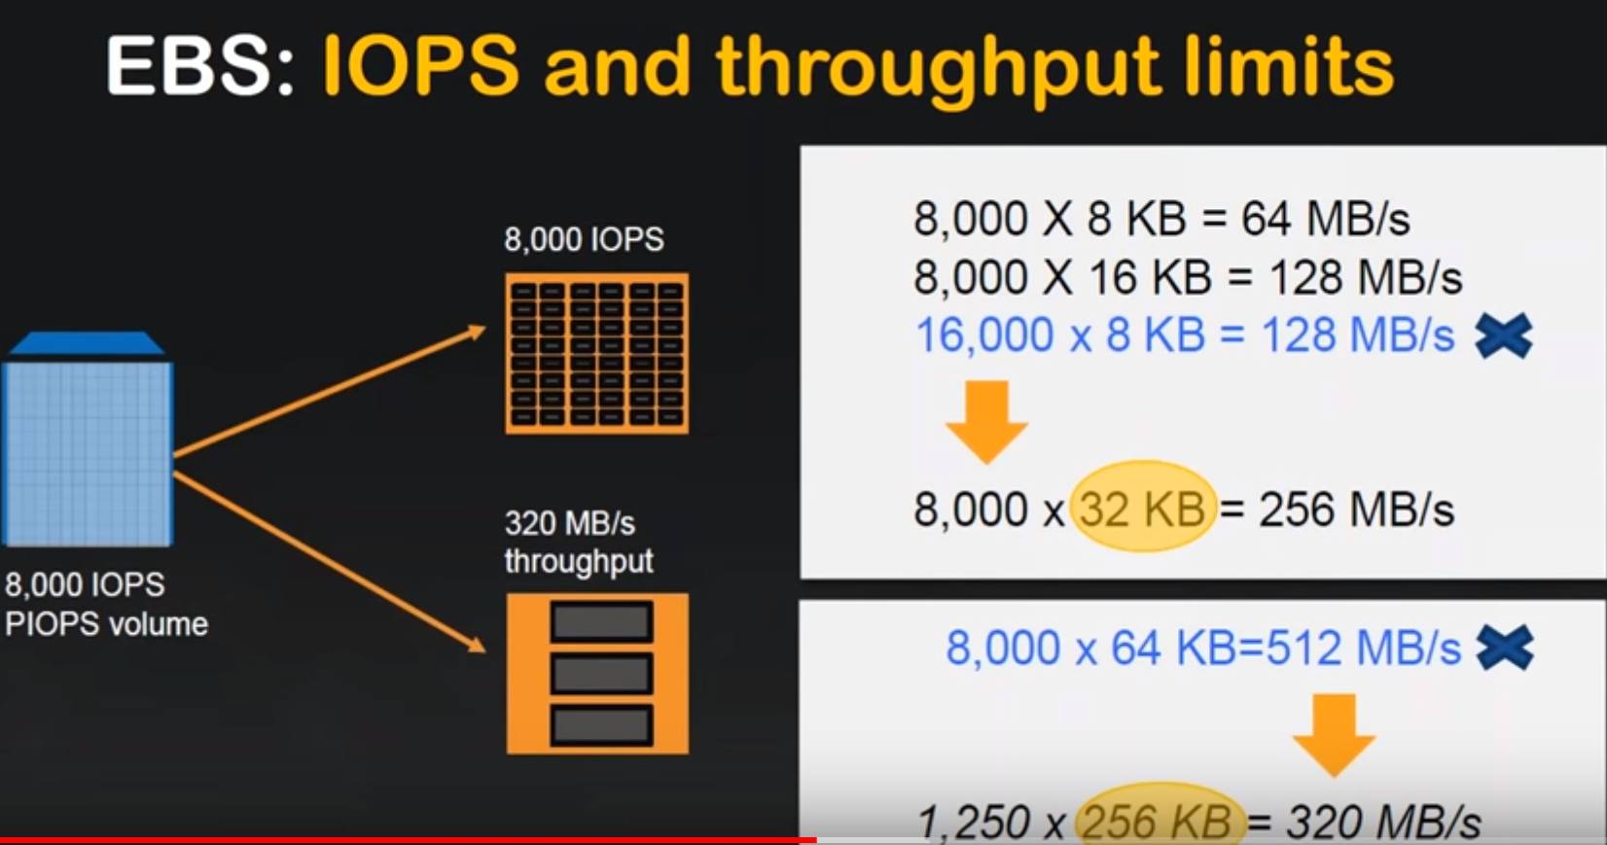

there is an upper limit for iOS and also for an upper limit for throughputs as well …

Here is a simple calculation of how you can achieve your 8,000 IOPS…

8 KB the multiples that you see here is the block level ….

this is here I'm writing 8 KB blocks and if I am doing 8 KB blocks in 8,000 the maximum that I can achieve is 64 Mbps only…

but if I'm going to split it into two… or if I'm going to have a 32 KB block amazon has optimized it for this number and if you achieve it for 32 KB then you'll have a maximum of 256 MBps…

-🡪So people who have not familiar with the block level you don't know how to really memorize it as I said you go and talk to your application team and find out **what is the block size that you are going to write from your application whether it is 8 KB or 16 KB or 32 KB whatever the number is then you multiply by the provision IOPS you set in your EBS volume..**

so a multiplication of this will give you the bandwidth in that disks .

**If you find that your application is slowing down, then you will see what is my IOPS that are for my server and what is the block size ….then you start working out in the reverse direction .**

**how do I choose which disk is right ????IOPS or throughput based????**

Amazon offers to broad-based categories at the top level…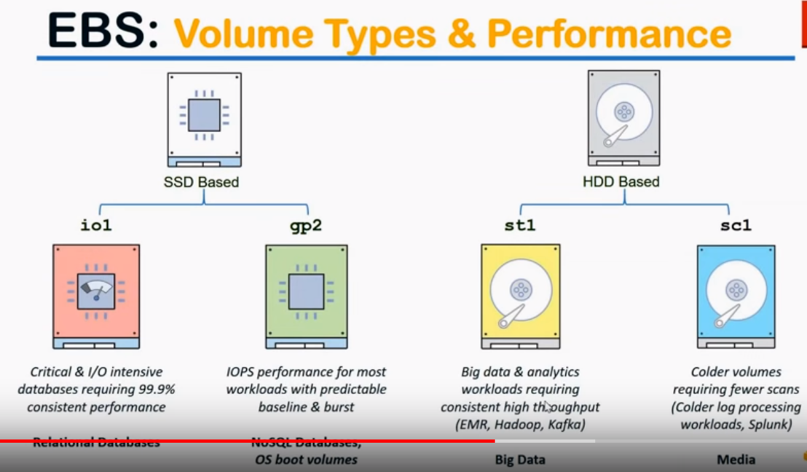

1.) SSD based disks ( solid-state disk). One of the fastest that you can get on the market

2.) typical magnetic spinning disk or spindle based disks : it is little cheaper but throughput that you can achieve with the spindle disks are really good and the longevity that you can get is also very high.

SSD: you get io1 and gp2…

**Io1:** Used for very high i/o intensive applications or a consistent database performance.

**GP2:** more baseline performance more predictable I am not worried about my peak performance I just want a predictable baseline… and whenever there is a burst capacity say for example suddenly there are as more users coming in for 5 or 10 minutes and then it's stable stabilizes after some time then gp2 is my best option…

**St1:** If I’m not going to burst… I am going to have a very consistent performance like throughout the day whatever application I am doing this is going to be my read and write like a big data analytics or a Hadoop based processing systems they will have a very consistent read write performance or throughout the lifetime of the cluster…

**SC1** : It is a cold storage where you are not worried about our performance but you want that most is cheaper stores block-level storage that is available to you and where you are going to do very slow processing of the data you are not worried about your performance so much..

log processing and some analytics of are all same processing and all those things sc1 makes the ideal

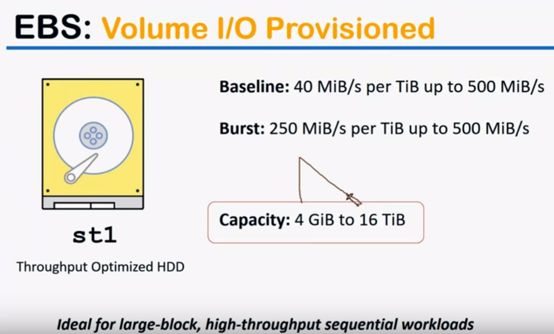

* capacity of that just goes from 4 gigabytes to about to 16 terabytes.. So that is a maximum volume size that you can achieve …
* With an st1 it is a throughput optimized to disk ideal for block storage and high throughput sequential workloads.. In other words think of it as video streaming or Hadoop cluster or those kind of systems…

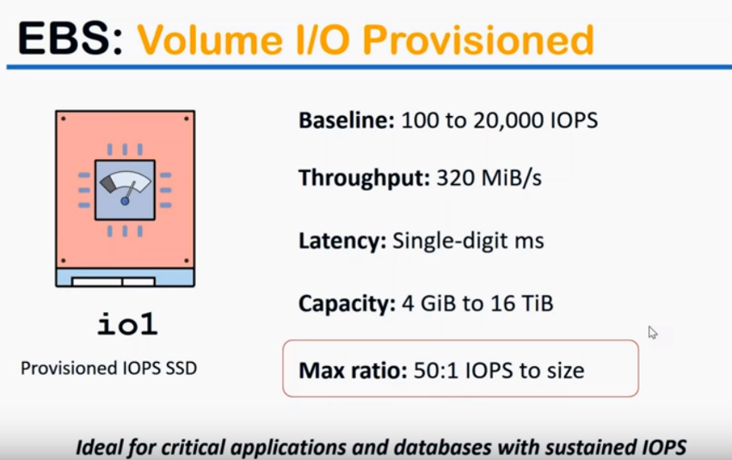

Here, IOPS performance is more important when you are talking about an SSD disks and in this case the max ratio is 15 is to one so that means that you can scale up to one is to 50 so 50 times more performance that you can achieve and ideally suited for critical applications and database with a very very high i/o you think of Flipkart or an Amazon during shopping festival in that cases the database will have a lot of requests and all happening very fast pace and all of them needs to have IO performance which is consistent with customer needs think of your at the payment gateway and there is a delay in the PIM you will most probably will be frustrated with that experience or not come to the same website so such thing I hope performance is one of the critical criteria for those kind of databases and I see Row one ideally delivers that for you so if I move forward this is a flowchart that I spoke about how would I choose which disk I need so how do I look at it is in the top you have your jobs and throughput and once you do your talk to occasion theme and find out what is the block size and calculate the IAP x' that you need and if you will get either one of these numbers and it's very simple it's a report from that if you need more than $65 and I ops you go to an I to baste it is and if it is less than 65,000 what is your latency requirement or how much time I can wait for the data so if you think that I cannot wait a list I mean I need to have a lesser than one millisecond latency then I will choose an I to pay status so if I can wait for once in one millisecond two milliseconds or something around that then I am going to ask you the question of what is the I of spur volume you need either remember this is at a total application level and this is at a four-disc level so if my disk each disk can have an eye office of less than 10,000 K I will go for this one and once again if I need more than 30,000 I end up being at I love Isay Row 1 itself so there is another desk likewise you navigate the chart on the right hand side also what is much smaller so through quota whether it is a random or sequential when I say random think of who you're playing a movie and you suddenly don't like the first ten scenes and you want to move to the half an hour forward into the movie so you're randomly seeking some date are there and whether the large sequential read is you're watching the movie sequentially one scene after another scene so that is what a random small evoke means sometimes people will seek and then do random i/o operations and if you are if this is going to be more than you only then solid state test but if it is always going to be a sequential data then you continue to put optimize to disk and follow it all the way down to the necessary volumes that you have here so not something to memorize but this is how you logically approach the problem of whether throughput optimise disk is good for me or I off to my disk is good for me and remember that you can change your size of your volume you can change the type of disks also in this case I am just showing you and it's a symbolic way of increasing your disk size let us say at the bottom if I want 5 GB disk and you want to increase it to 50 GB you can put your console and change your size anytime and in this case I'm saying staying in the same group where the gp2 becomes a bigger GP to a zero one becomes an bigger eysie row 1 and it goes on likewise so this is absolutely possible but there is a caveat here you cannot do this you cannot have come down here the reason for that is once you go up here Amazon assumes that you have put more data let us say your know 5 a to 50 GB and you stored about 40 GB of data there and when you try to dynamically resize it ms one doesn't know where your data is residing and that's the possible of where data loss or corruption is possible so dynamically they don't allow you to resize your data I mean resize your disk to a smaller number so the only way to do that is you take a snapshot which will copy only the amount of data that is in your disk and put it into another volume of smaller size so that is only way you can resize it so if anybody asks you how do I resize the word only simplest answer is I will take a snapshot and create a volume from my snapshot so let us move forward what other disk level operations is possible I can whether I can decrease my volume we just now spoke about it no that is not possible I need to take a snapshot of it so changing volume types if you carefully notice here I am changing from one volume type to another volume paper from gp2 to IC row one that is also possible from here in this case I can go from I 0 to 2 i 0 what if you are wondering why would I want to director say for example you are thinking that your application is true put optimized but after the starting to find unit and working with disk level experts you understand that it is no longer true good optimized but it is I worked in my step so in those cases you might find the need from switching from one type of volume to another type of volume okay as you can see here the image this is an SSD disk and this is a solid state I mean this is in solid state disk and this is one is a magnetic spinning disk so you might want to shift from one volume to another volume it is not always all combinations are possible there are certain combinations are possible depending upon what is your source then you can choose your font or create disk combination with where you can go to so remember that changing volume types is possible with some limitations so this another performance I of increase so I say the image that shows here you can increase your i/o performance also from 10000 I officer 20,000 a ops and from 20,000 you can come back to fight those and not expose it also that is also possible increased as well as decrease both or possible in terms of AI ops cases so that is another disk level of collisions allowed and finally you can combine in different modifications we just now spoke about it this is the tricky part don't try to memorize it or by heart rate you just remember that different disk level combinations are possible but not all the combinations are available here so this gp2 becomes a bigger size io one if it is a combination of different things it is not just time change size change is also there performance changes also that is what I am trying to show here in this slide and finally some use cases so as you can see here if you have a hot data which is used for receive up to seven days then you use the TP - I'm just giving you a different use cases which you might have come across in your real life scenarios if your customer says that I have data which is actively accessed a single day just go ahead and recommend them at cb2 and if you say that i need a warm date I won't stand by then you tell them that the sd1 is good for you so that is how you choose here is another use case at the bottom let's think of an SQL Server database that you have and in the single SQL Server itself you will have a different type of storage requirements one for a backup one for transaction logs and also for partial backups so I can configure these kind of different storage st-1 itself or if I you think that the full backup is not going to be accessed every single day I can even point finger the cold data storage for that backup so instead of st-1 I can perform sc1 also and in the right hand side have such as shown that actual data files can be in gp2 also to improve the performance as you can see there is an SSD base to disk so the actual data here I'm just talking about this one the actual data will be more faster fourth read and write operations and whereas the commit logs will be in SD one that is a spinning disk so that is the background conceptual part of EBS volumes thanks for listening patiently